Kubernetes Activity 4 :

Create a new folder “caddyReplica” in visual studio and under that create an “act4-deployment.yml” file

Deploy the caddy replica set

Now get the pods, got 3 pods for caddy replica

Modify the image name now in act4-deployment.yml file

Apply the changes and do the deployment

Now describe the deployment, caddy changed to ngnix

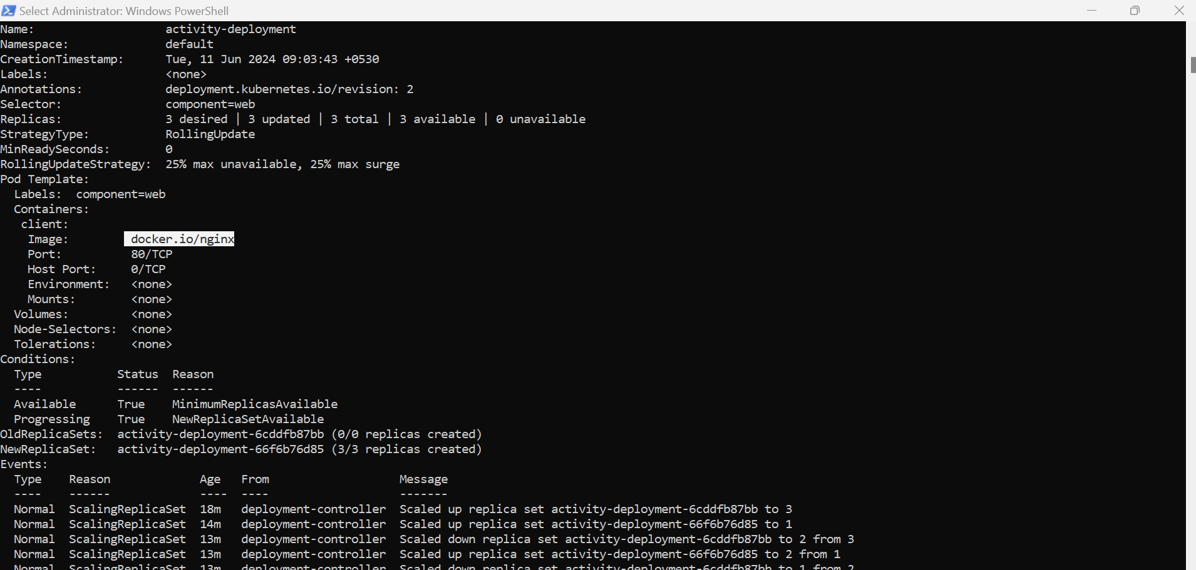

Now roll back the changes

Again describe the deployment, ngnix changed back to caddy

